

**HO CHI MINH CITY UNIVERSITY OF TECHNOLOGY AND EDUCATION**

**FACULTY FOR HIGH QUALITY TRAINING**

**🙡🕮🙣**



**SUBJECT: DRIVE SERVO SYSTEMS**

**GROUP**

**FINAL REPORT**

**POSITION AND VELOCITY CONTROL DC SERVO MOTOR WITH PID**

|  |  |
| --- | --- |
| **Lecturer: Võ Lâm Chương** | |
| **Students** | **ID** |
| **Huỳnh Anh Duy** | **20146031** |
| **Nguyễn Hải Hoàng** | **20146004** |
| **Trần Phúc Thịnh** | **20146028** |
| **Monday – Period 10-12** | |
| **Class: SERV334029E_22_1_02CLC** | |

**Ho Chi Minh city, January 2023**

**Chapter 1: DESIGN AND IMPLEMENTATION**

**1.1 Mechanical design**

We used the data sheet of Sanyo Denki DC servo motor KB406 24V 60W since it is more approachable, which has nearly the same specification with Sanyo Denki DC servo motor R720 30V 65W we used in our model.

|  |  |
| --- | --- |
| **Motor** | **KB406** |
| **Back EMF Const, Ke (V/krpm)** | 5.9 |
| **Torque Const., Kt (Nm/A)** | 0.056 |
| **DC Resistance, R (Ω)** | 0.94 |
| **Inductance, L (mH)_** | 0.5 |
| **Inertia, JM (x10-4 kg.m2)** | 0.108 |
| **Viscous Coefficient** | 0 |

**Convert Ke unit (V/krpm) to (V/rad/s)**

Ke = $\frac{5.9 . 60}{1000 . 2Π}$ = 0.056 V/rad/s

**Response time**

τ = $\frac{R . J_{M}}{Kt . Ke}$ = $\frac{0.94 × 0.108 ×{10}^{-4}}{0.056 × 0.056}$ = 3.24 x 10-3 (s)

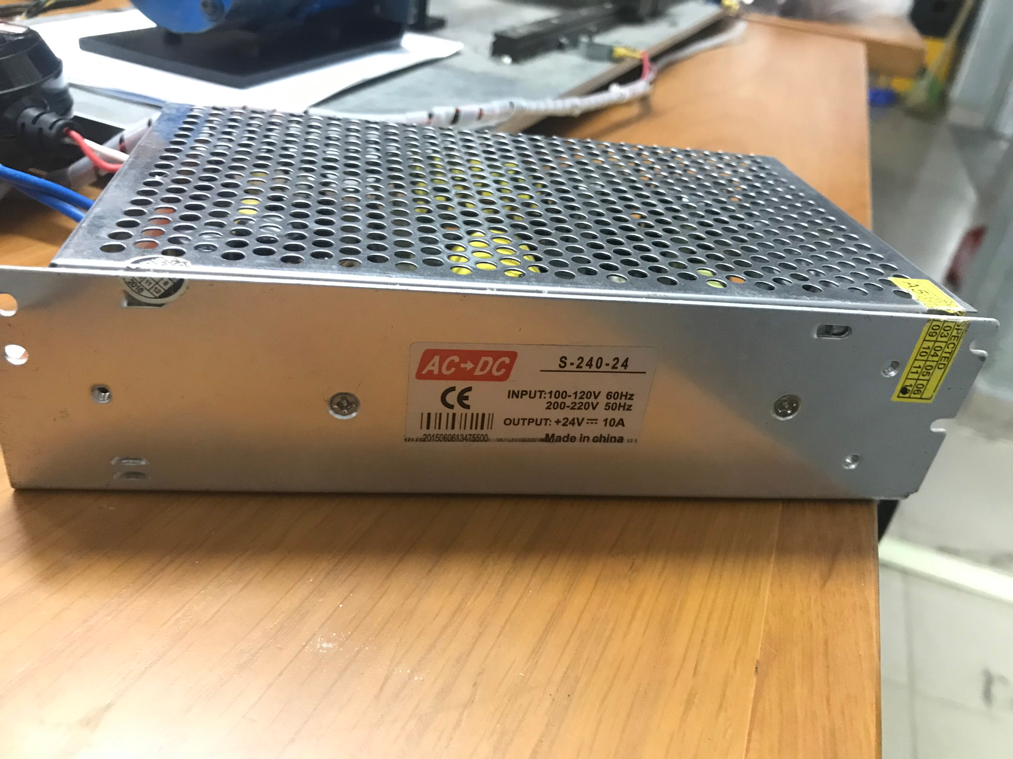

Figure 1. 1: Switched-mode power supply 24V

Converts from a different supply voltage (usually AC supply voltage) to a direct current (DC) mains voltage.

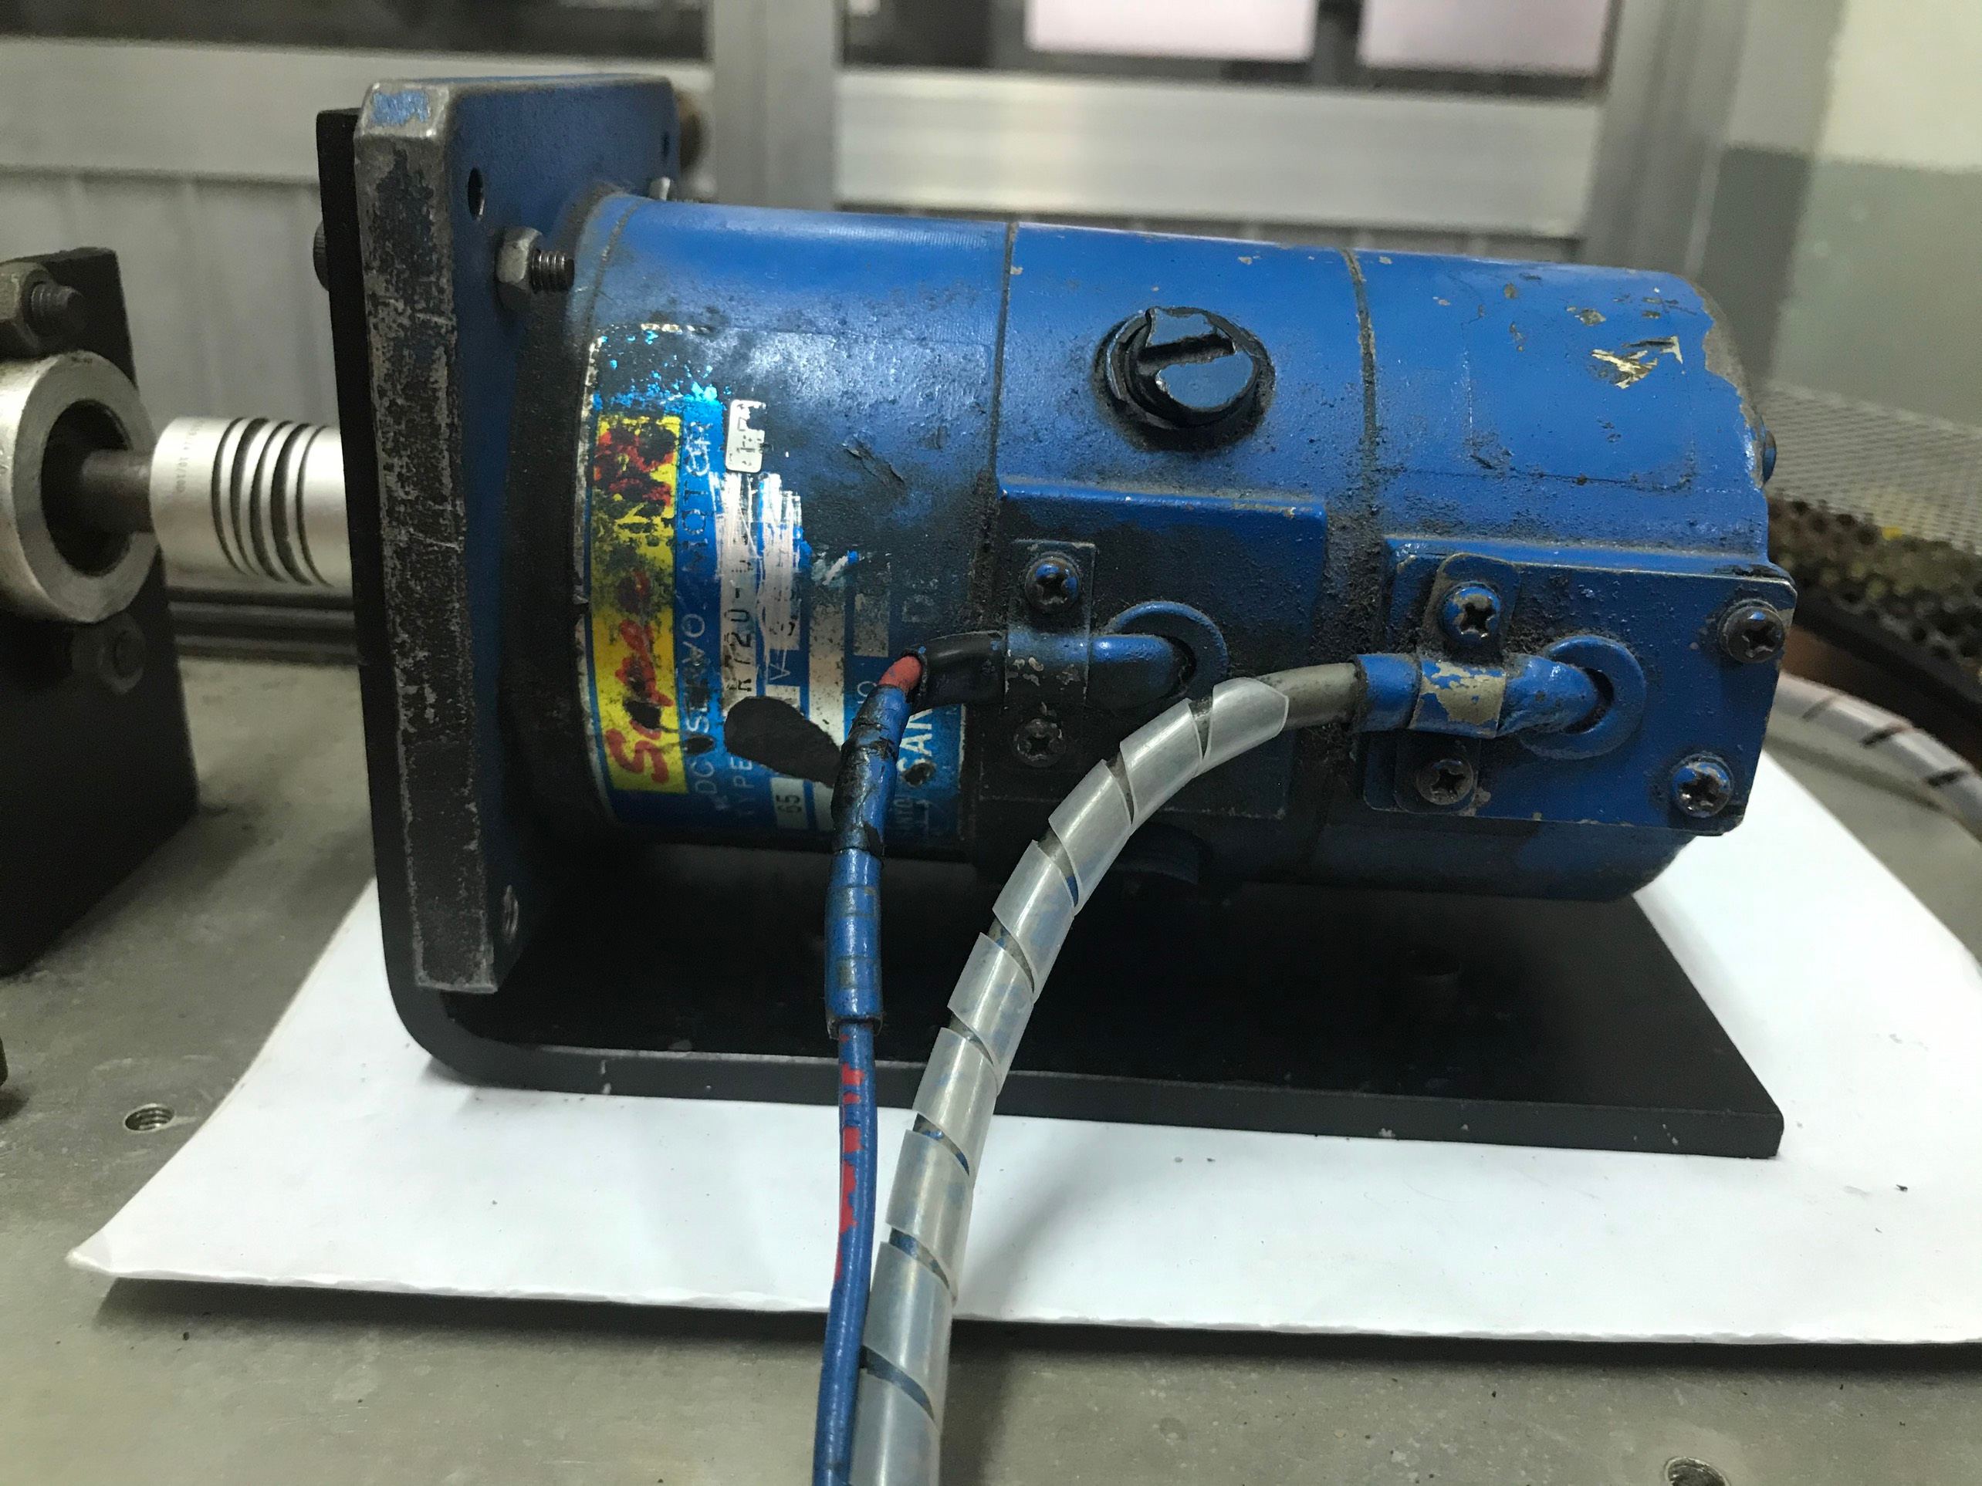

Figure 1. 2: Sanyo Denki DC servo motor R720 30V 65W

Uses DC electrical input to produce mechanical output like position, velocity, or acceleration

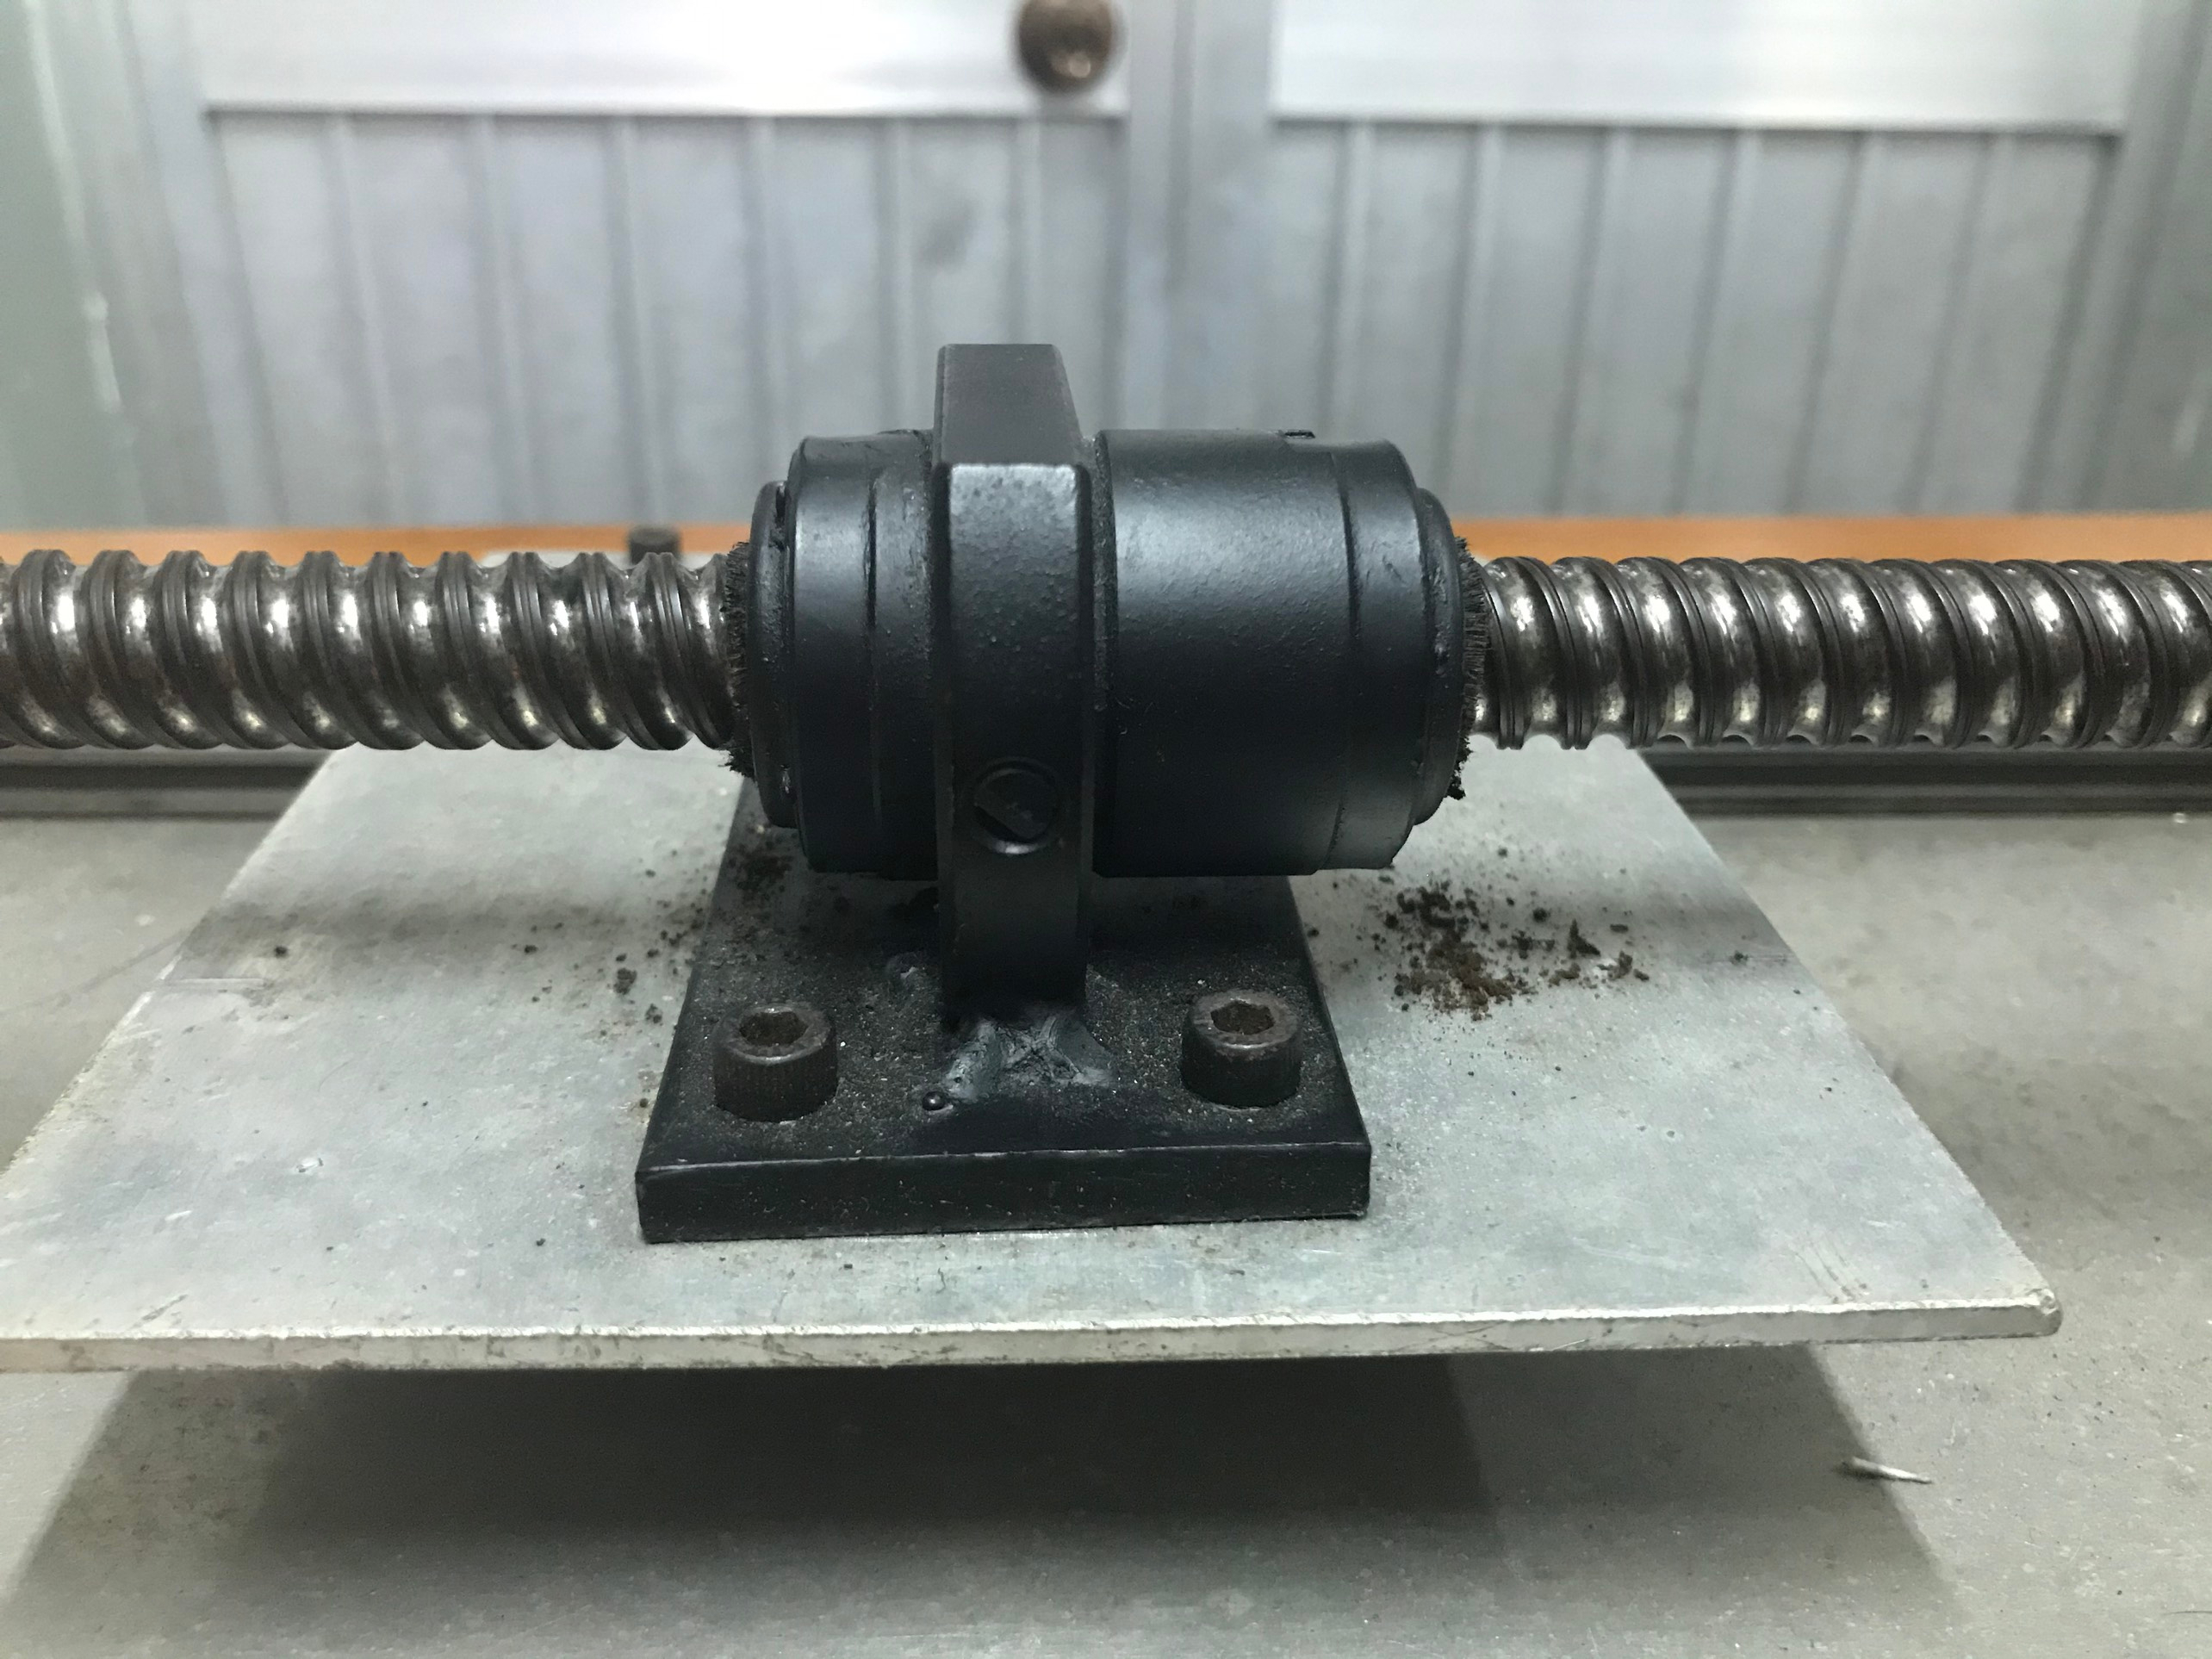

Figure 1. 3: Ball screw nut

Converts rotational motion to linear motion. Apply or withstand high thrust loads with minimum internal friction.

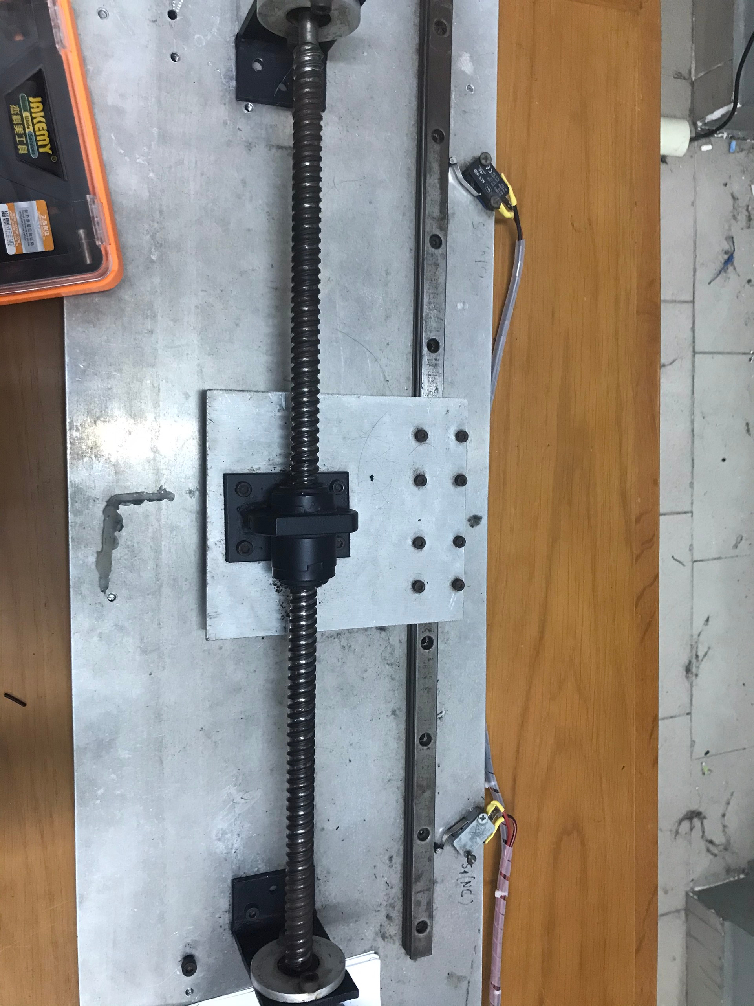

Figure 1. 4: 470mm screw shaft

Holds objects together and to transmit torque and rotation. In this case, a ball screw nut is mounted on the screw shaft so that we can study and report the position.

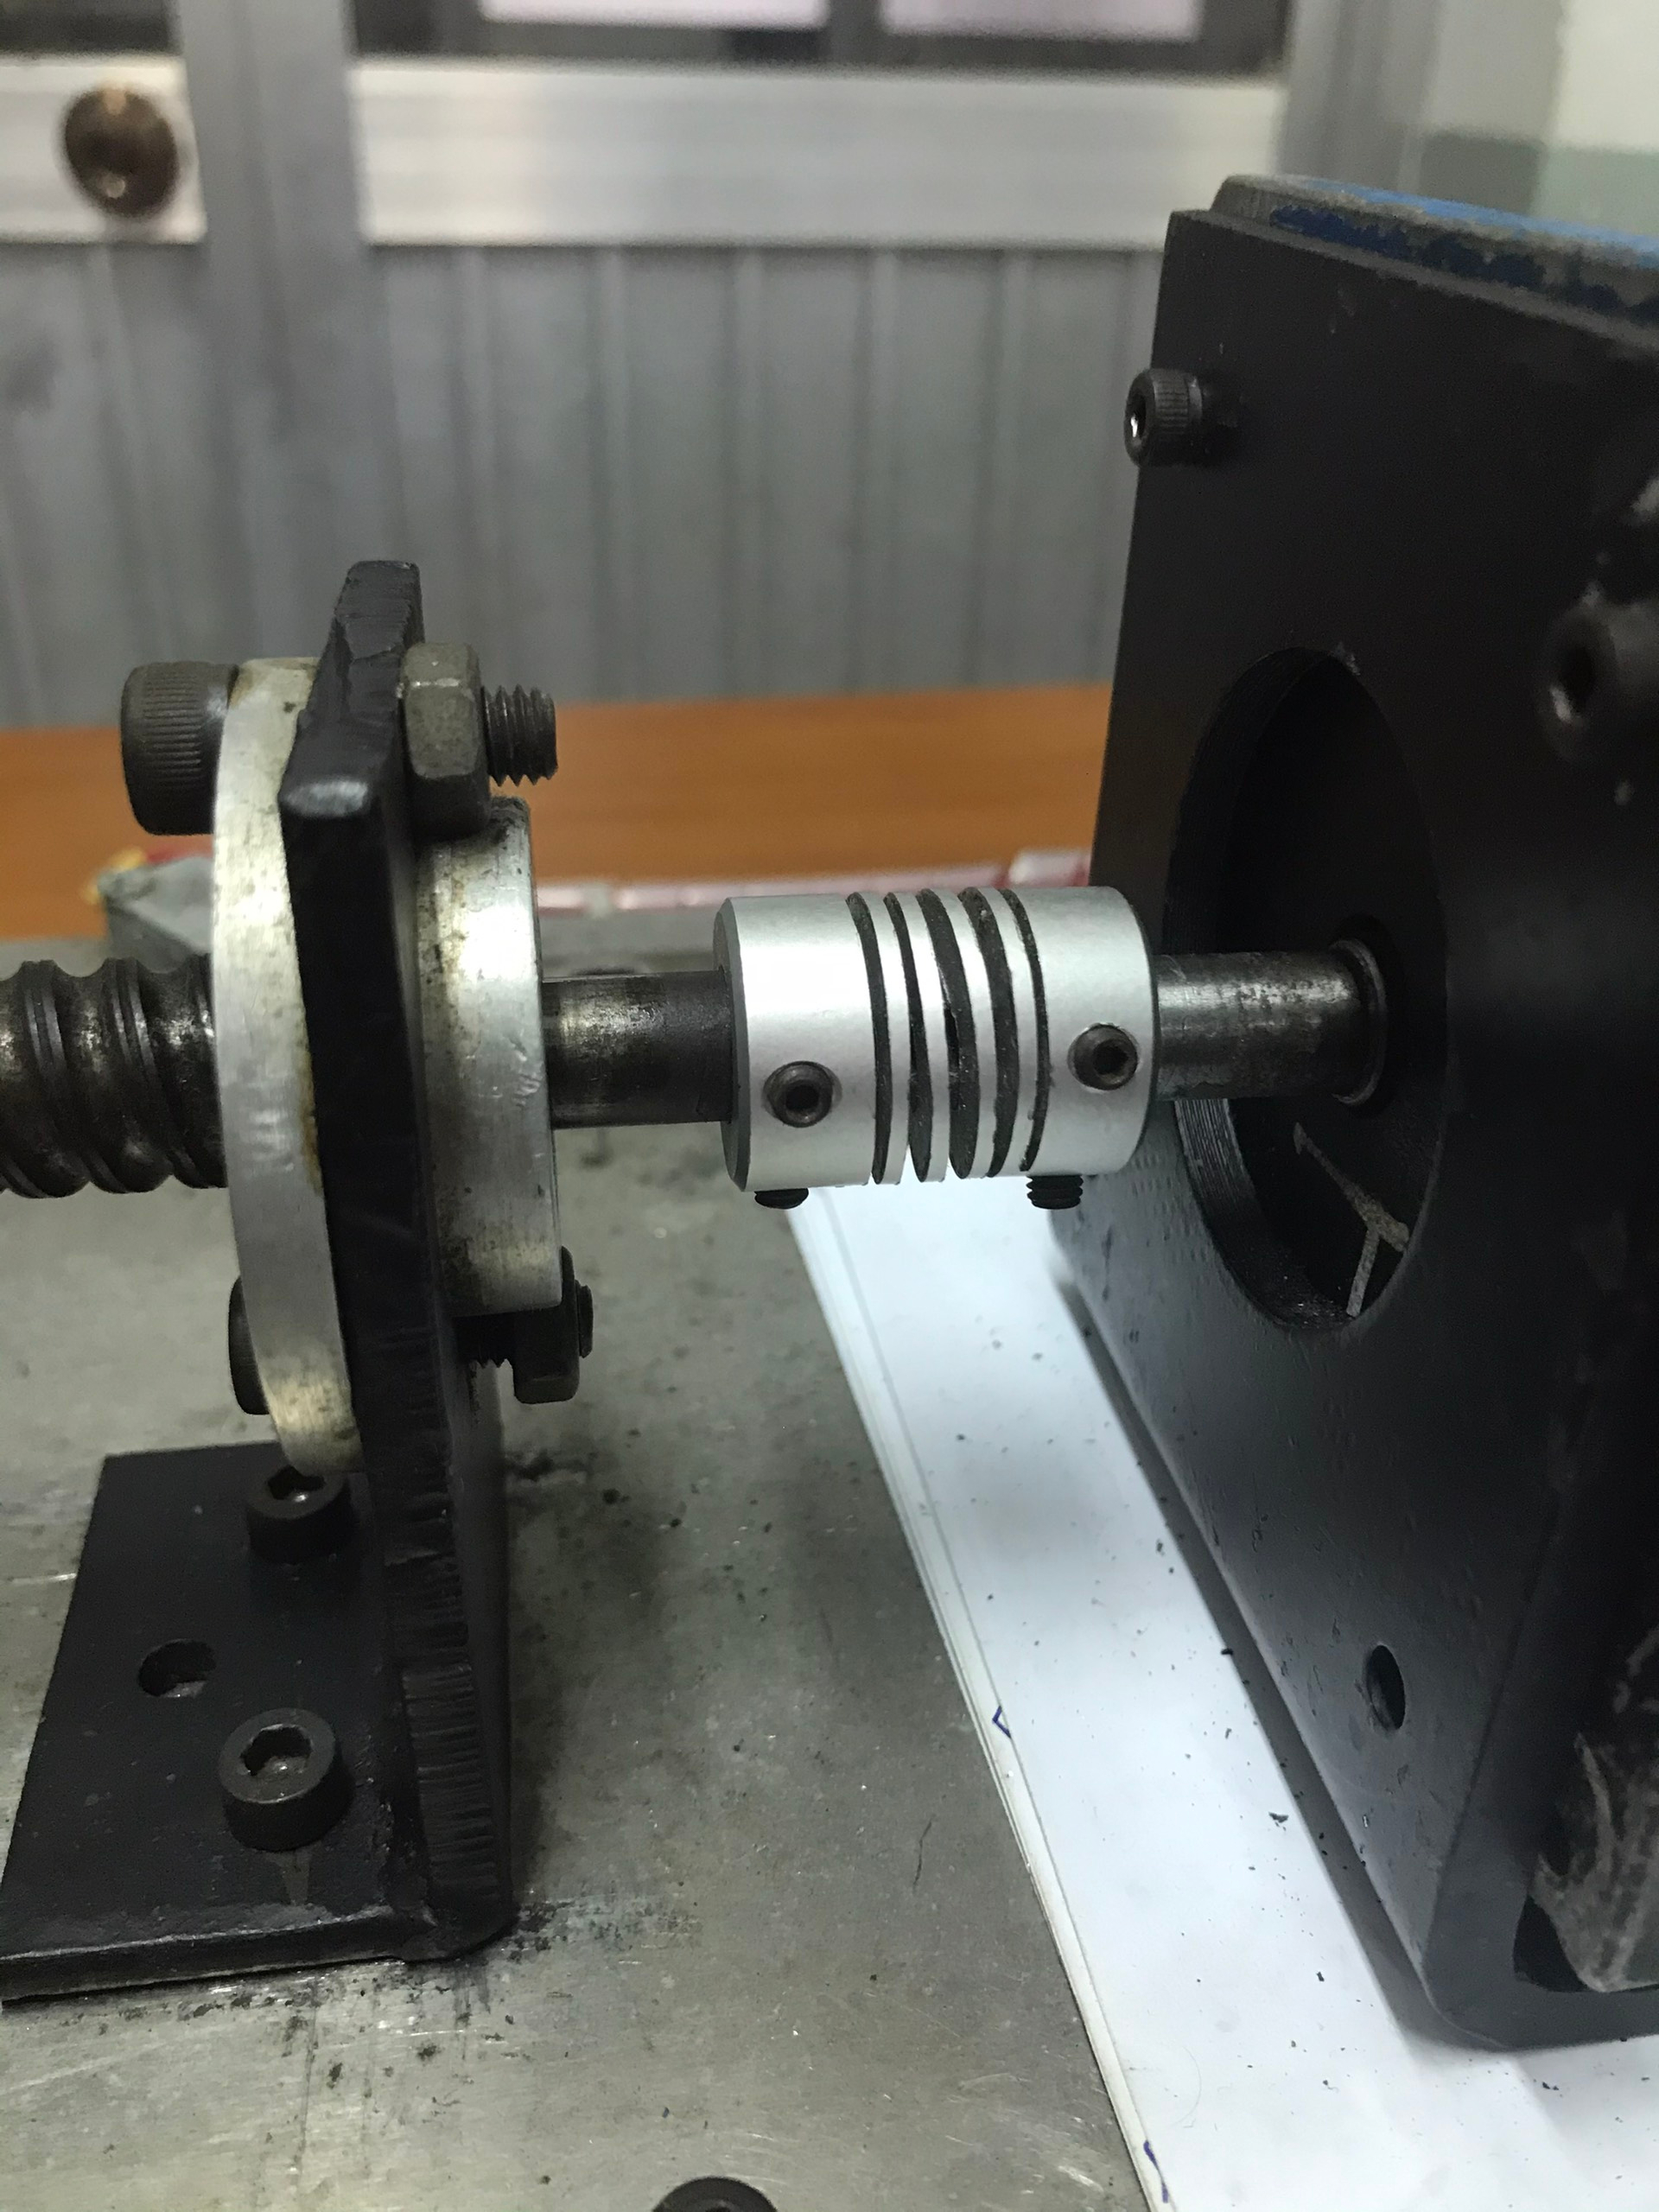

Figure 1. 5: Shaft coupling

Connects two shafts together to accurately transmit the power from the drive side to the driven side while absorbing the mounting error (misalignment), etc. of the two shafts. In this case, it is used to make motor shaft concentric with load.

**1.2 Electrical design**

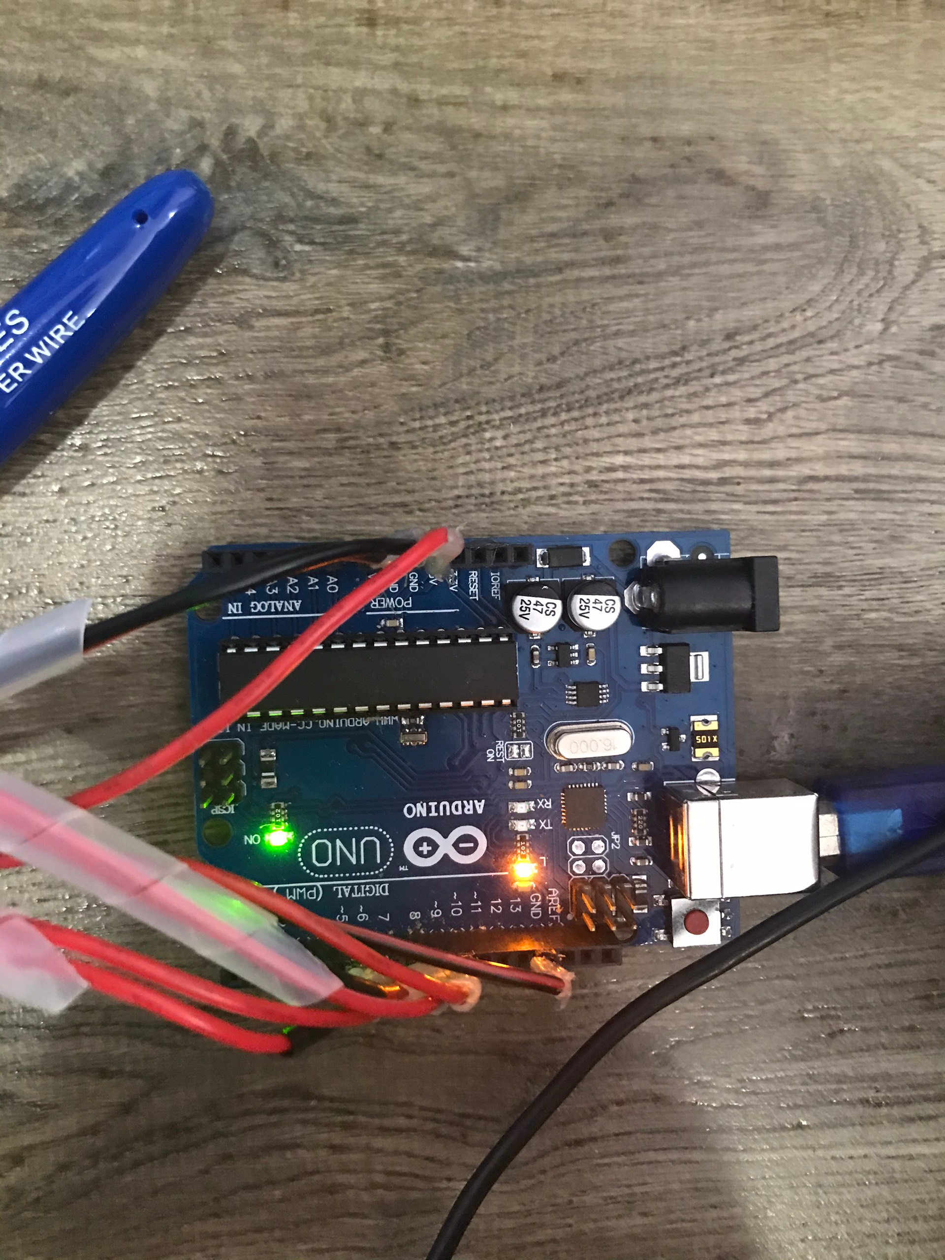

Figure 1. 6: Arduino Uno

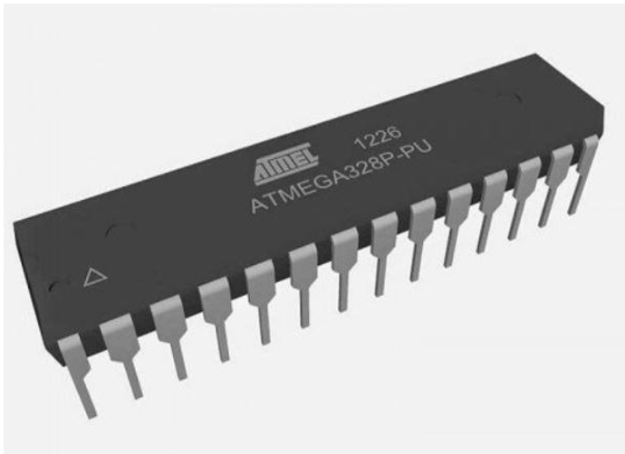

Figure 1. 7: Micro-controller Atmega328P-PU

Applied in DC servo motor to produce the PWM signal.When declaring PWM pulse modulation at a certain frequency and pulse width, the microcontroller will perform pulse output continuously and automatically until there is a change in new pulse width values. PID controllers are realized by using microcontroller to the DC servo motor.They are used to control position of the Dc servo motor, while PI controllers are used to control velocity instead.

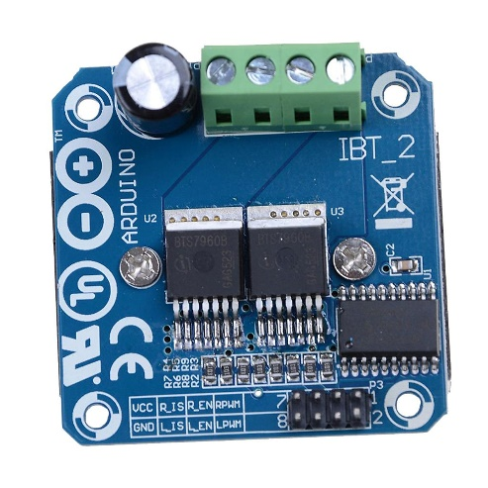

Figure 1. 8: H bridge BTS 7960

Used to control a DC servo motor to rotate forward or reverse and controls the flow of current to a load. Depends on how we choose components with large or small current, control voltage, PWM frequency,…, they will determine the controllability of the H-bridge. It is able to withhold with 43 Ampe.

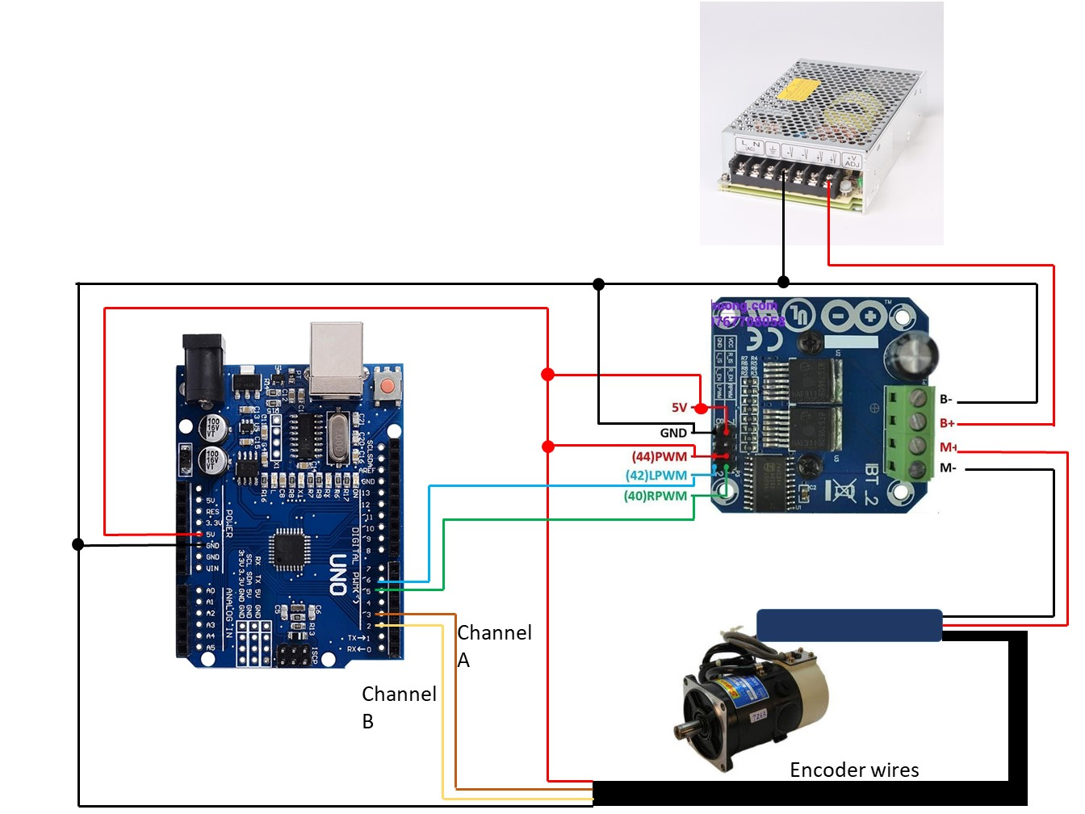

Figure 1. 9: System wiring

This is the system wring from the microprocessor, through H bridge BTS 7960 and connect with DC servo motor. The motor is powered by a 24VDC power supply after converting from 220VAC. The DC servo’s encoder has 2 channels, which are connected to pin 2 and 3, respectively. The LPWM and RPWM signal pin of the H bridge is pin 5 and 6 of Arduino UNO, respectively. Finally, the encoder and H bridge is powered by the 5V power supply from the microprocessor, and common ground connection between port B- of H bridge and other ground pin.

**1.3 Controller design**

**The P-term is calculated as follows**

$$u_{k}^{P}=k_{P}.e_{k}$$

**Anti-windup**

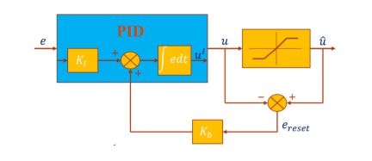

Figure 1. 10: Closed-loop block with PID controller

$$u_{k}^{i}=u_{k-1}^{i}+k_{1}.T.e_{k}+k_{b}.T.e_{k}^{reset}$$

**Low pass filter:**

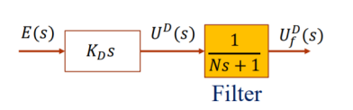

Figure 1. 11: Low pass filter

$$u_{f}^{D}\left(k\right)=\frac{N}{N+T}u_{f}^{D}\left(k-1\right)+\frac{K_{D}}{N+T}\left(ⅇ\left(k\right)-ⅇ\left(k-1\right)\right)$$

**The PID parameters include a derivative filter for the term D and an inverse filter for the term I**

$$u_{k}=u_{k}^{I}+u_{k}^{P}+u_{f}^{D}$$

**1.3.1 Position control with PID**

**Code:**

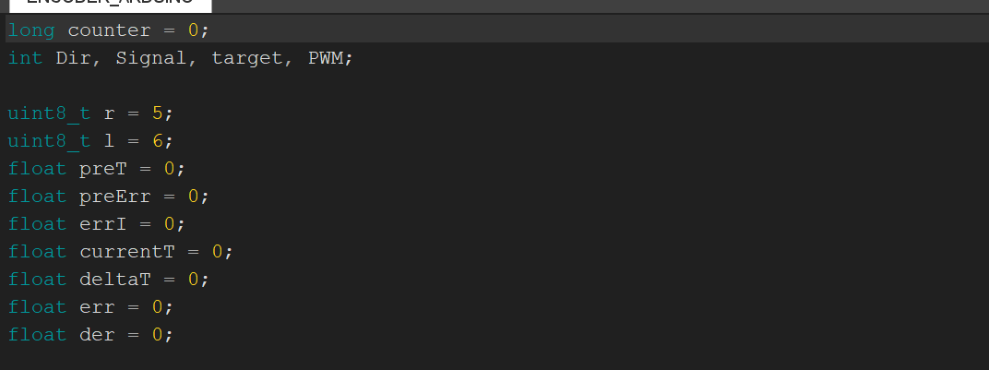

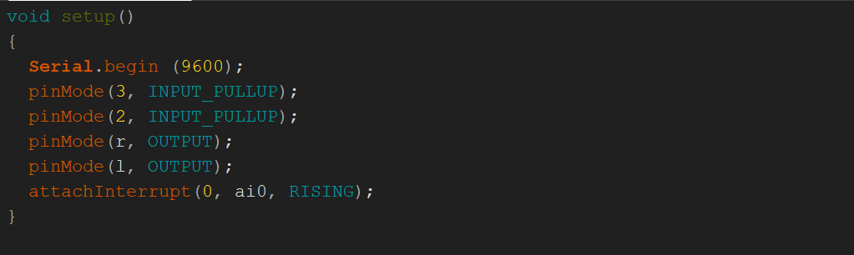



We set one input pin in external interrupt mode and read the encoder data with x1 Encoding code.



Next, we set the data input from serial monitor window equal to different target pulse destination. In our system, 1 rotation of motor’s shaft = 500 pulse.

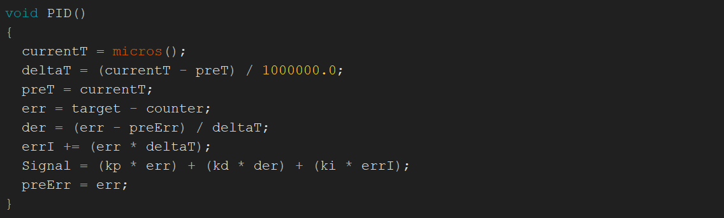



PID function, processing feedback data and output signal to control position with PID controller. After several times testing with our model, we manage to find a suitable Kp = 1.28, Ki = 0.0005 and Kd = 0.01.

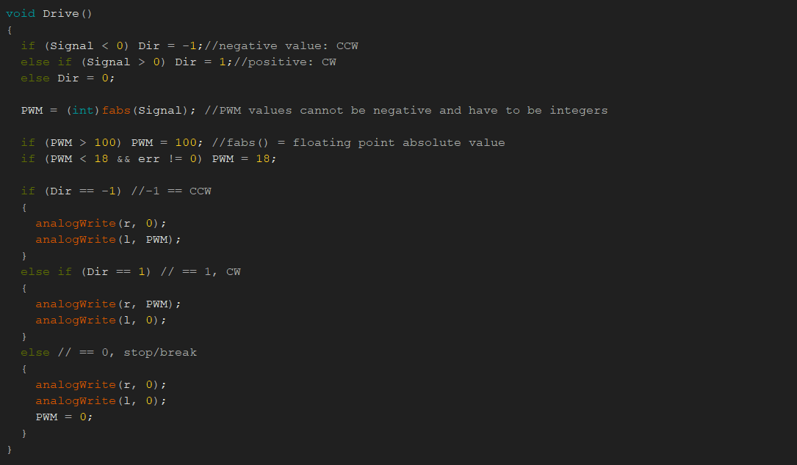

Finally, the Drive function, controlling the limit of PWM pulse width and direction of DC servo motor.

**1.3.2 Velocity control with PID**

**Code:**

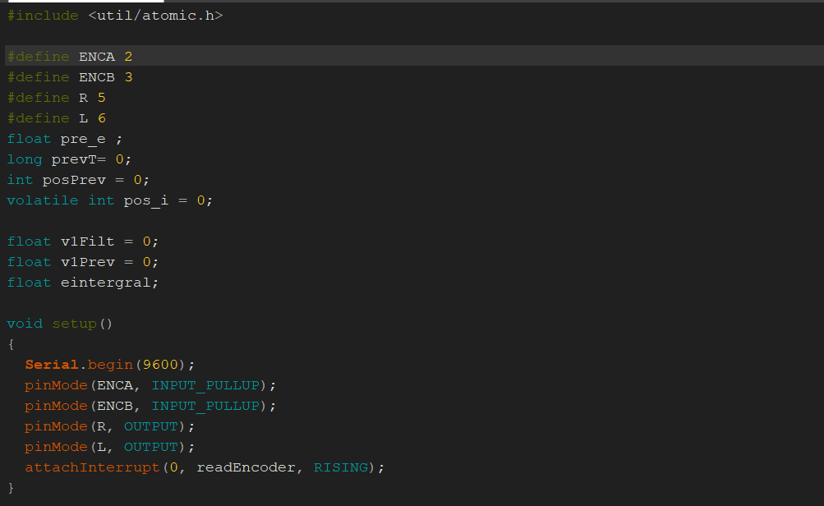

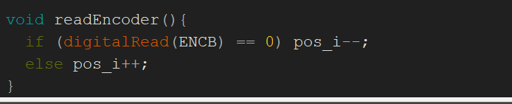

Set up pin mode and read encoder feedback with x1 Encoding code, using 1 external interrupt pin and 1 input pin.

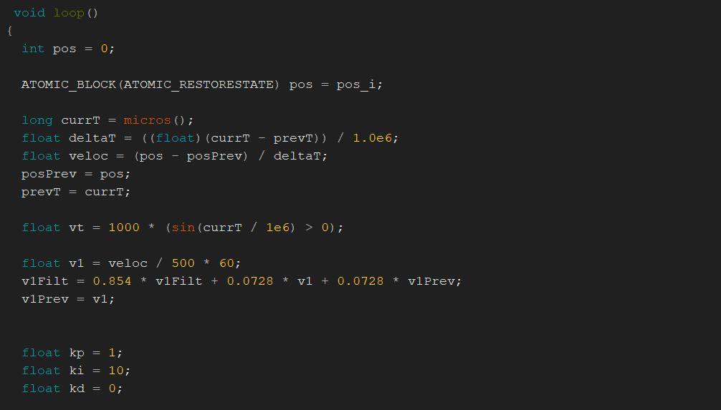

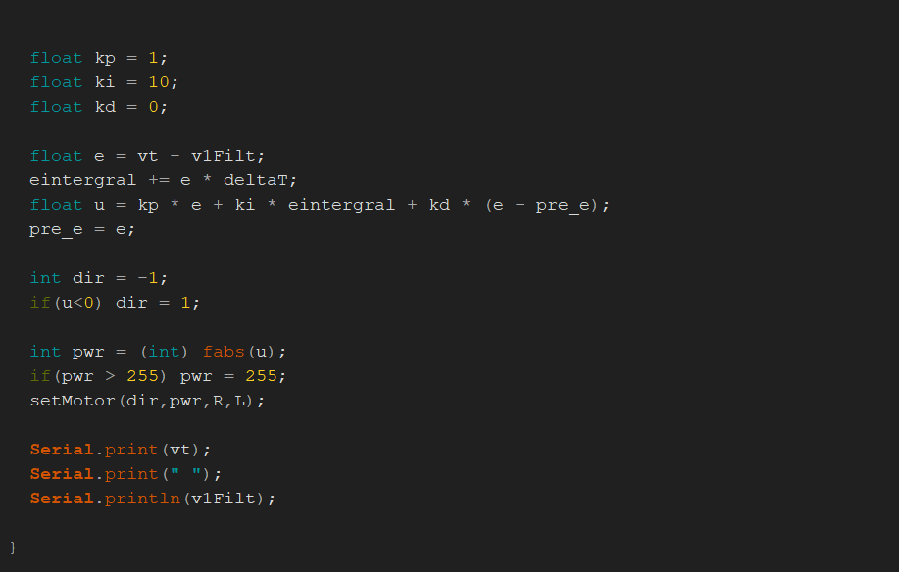

PID function, processing feedback data and output signal to control velocity with PID controller. After several times testing with our model, we manage to find a suitable Kp = 1, Ki = 10 and Kd = 0. Our group chooses to skip D-term in controlling DC servo motor because the motor characteristics have the formula $\frac{K}{τ_{M}s+1}$ is a first-order phase, so D-term doesn't need to be used. In this system, our group **only uses PI-term so D-term is equal to 0.**

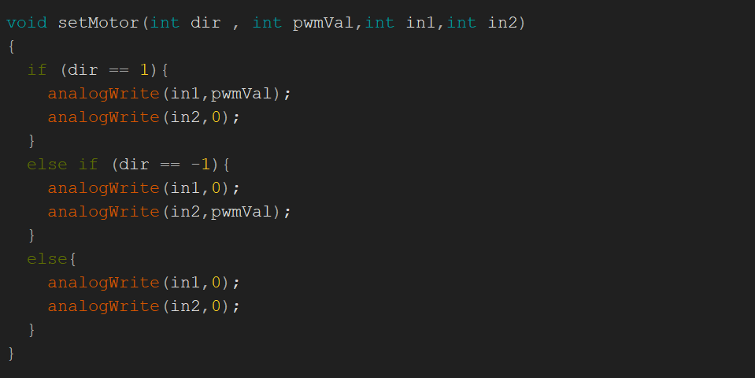

Finally, the Drive function, controlling the limit of PWM pulse width and direction of DC servo motor.

**Chapter 2: EXPERIMENT RESULTS/ FINDINGS AND ANALYSIS**

